**Task 15: Docker Networking**

**Docker Networking:**

* Docker networking refers to the system Docker uses to enable communication between containers, the host machine, and external networks.
* It is a fundamental part of Docker, allowing containers to exchange data securely and efficiently, as well as connect to services outside the containerized environment.

**Types of Docker Networks:**

1. **Bridge Network (Default for Standalone Containers):**
   * Containers on the same bridge network can communicate directly.
   * Uses a virtual switch to route traffic between containers and the host.
2. **Host Network:**
   * Shares the host machine's network stack.
   * Containers bypass Dockers’ virtual network layer, leading to higher performance but less isolation.
3. **None Network:**
   * Disables networking for a container.
   * Used for isolated workloads or when networking isn't required.

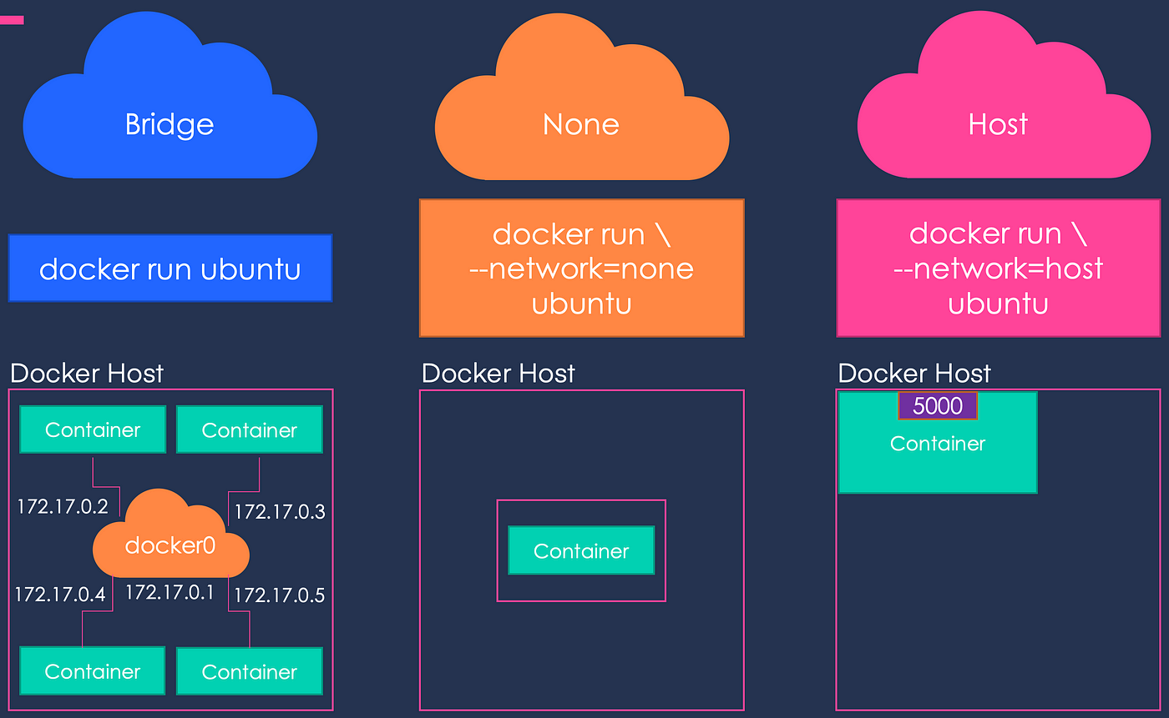

1. **An Ec2 Instance launched and Docker Installed**

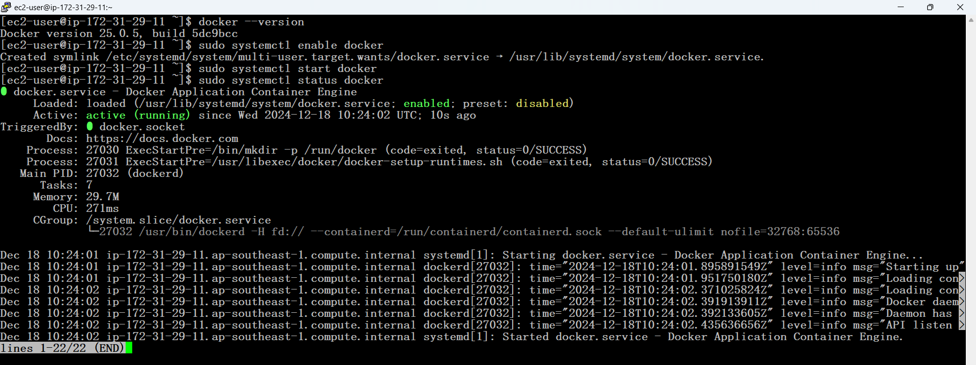

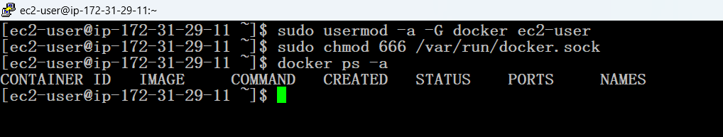

1. **Pulled some images from Docker Hub**

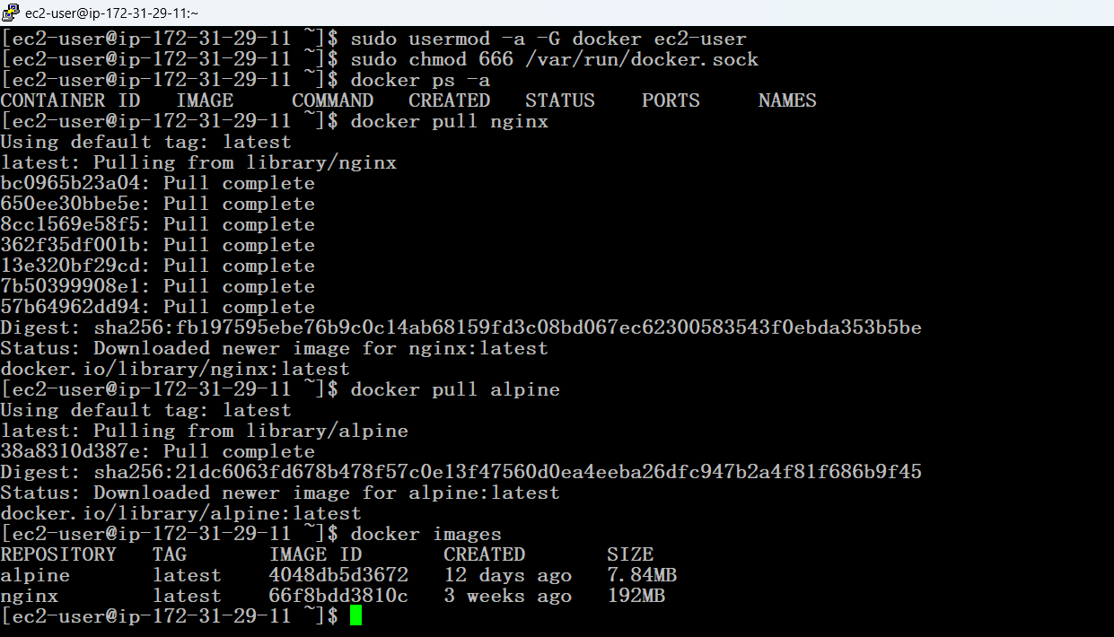

1. **Updated the SG for hosting the Containers**

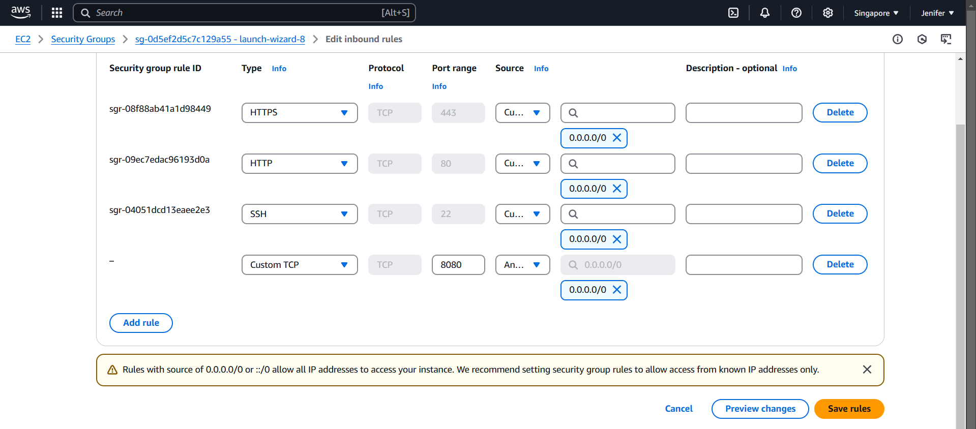

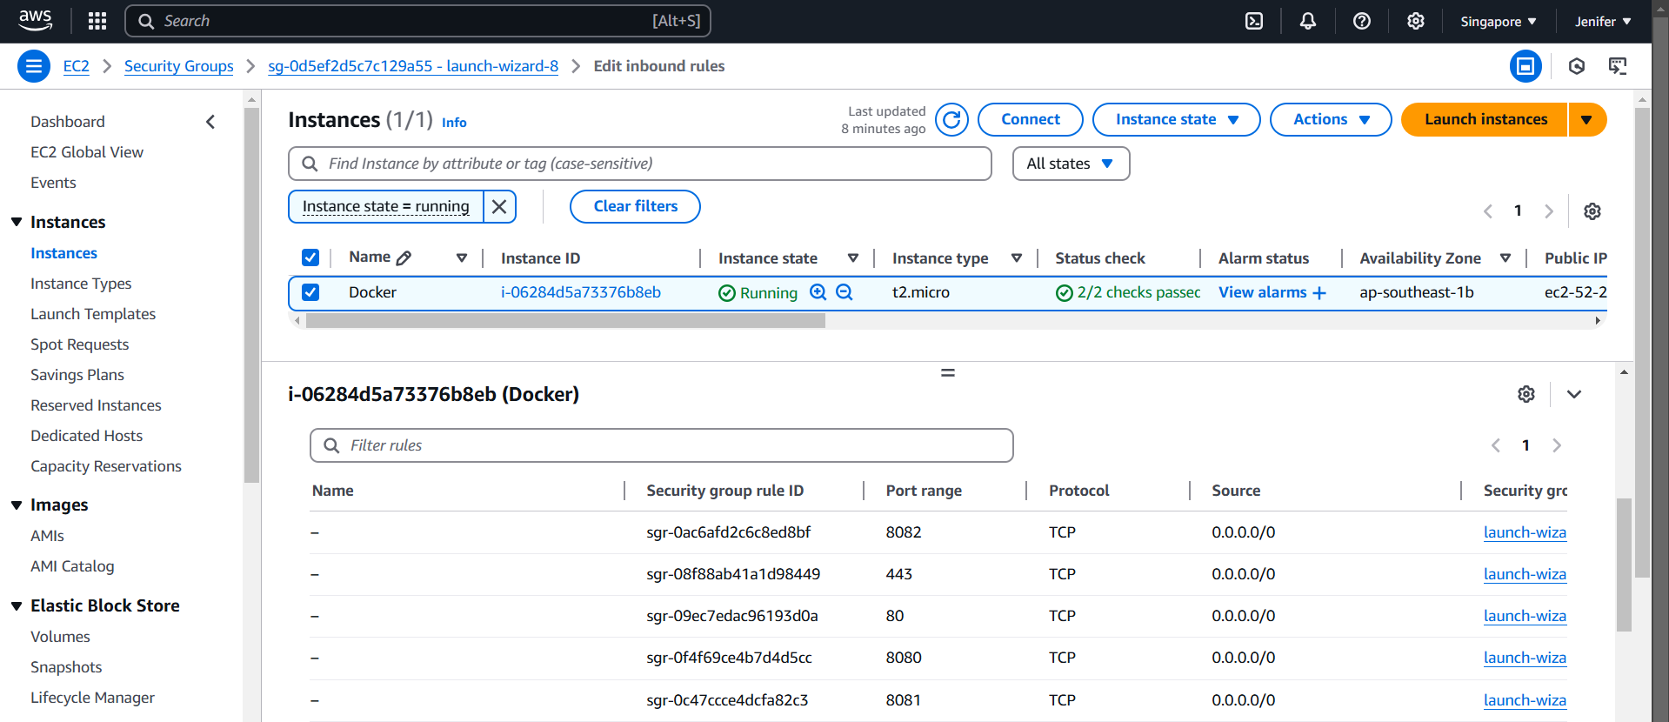

* The **bridge network** is Dockers’ **default network mode**, allowing containers to communicate with each other and the host machine on a virtual private network. It creates a virtual bridge that connects containers to the host’s network, isolating them from other external networks.

**Establishing Bridge N/W between Containers**

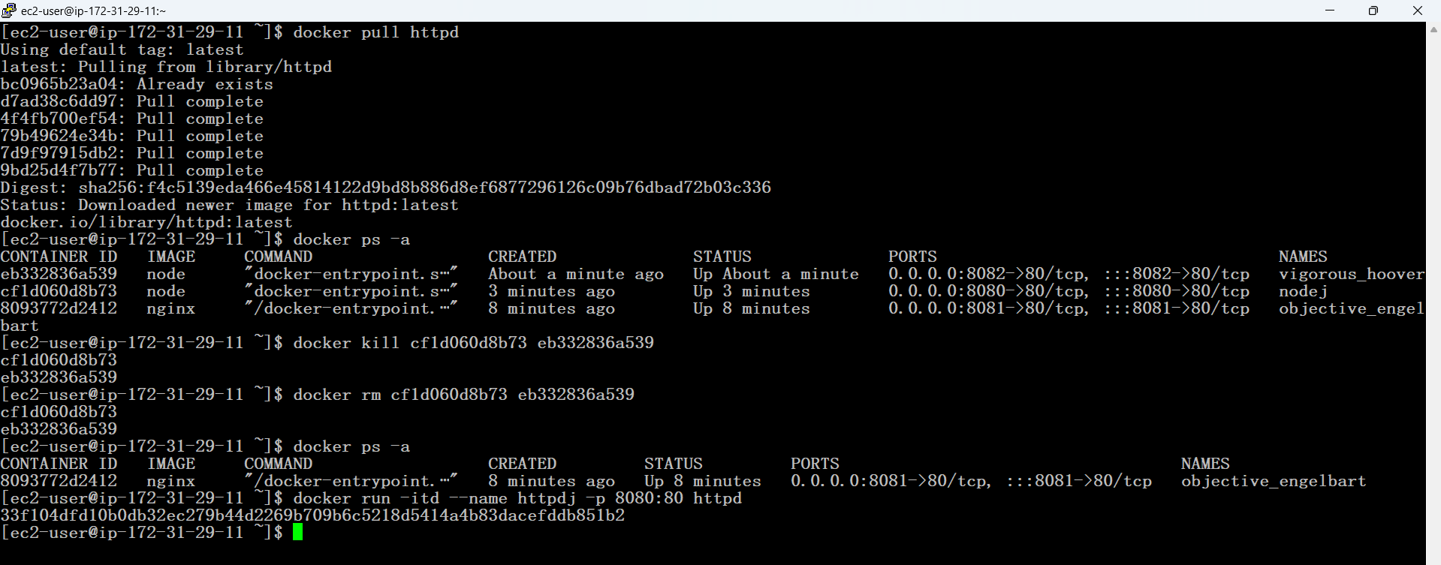

**We can host our application on a particular PORT**



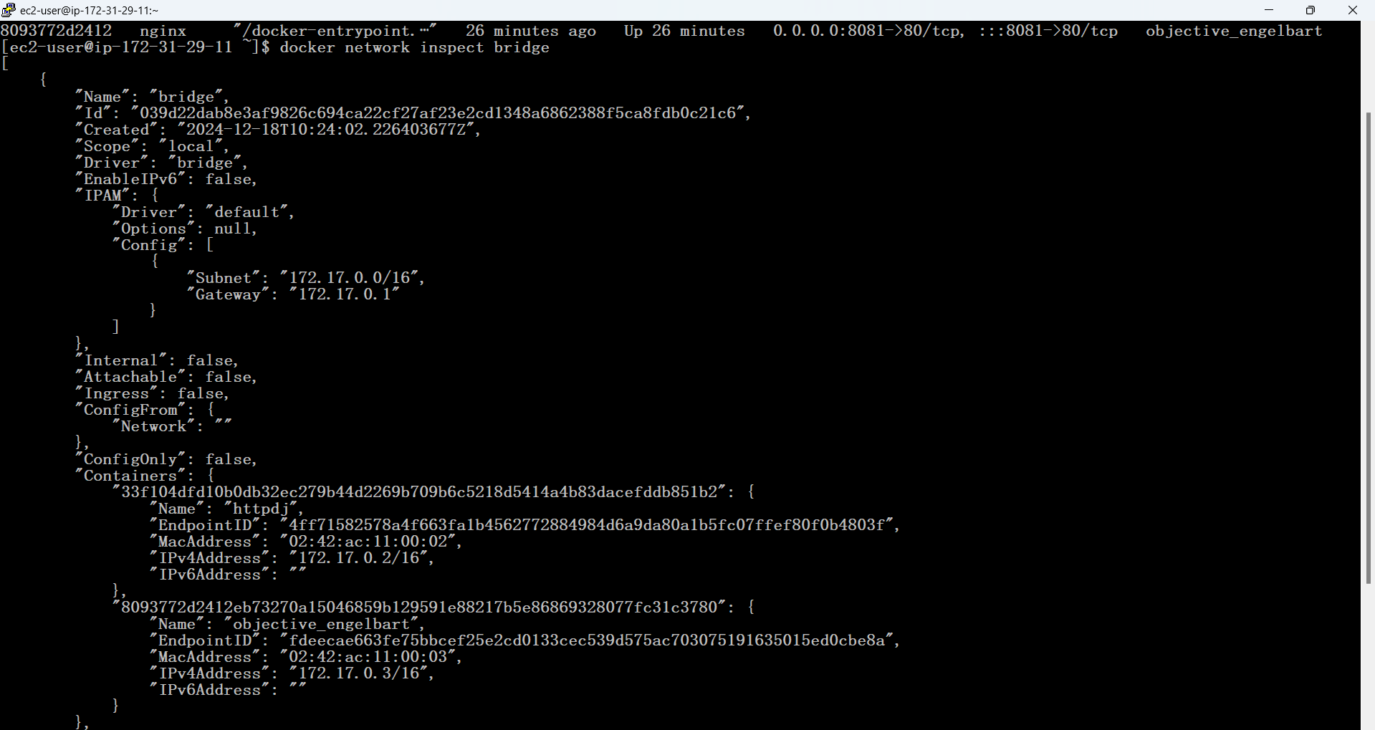

**Host N/W Mode:**

* The **host network mode** in Docker allows a container to use the **host machine's network stack** directly. This means the container does not have its own network interface; instead, it shares the host's IP address and can directly access the host's network interfaces and ports.

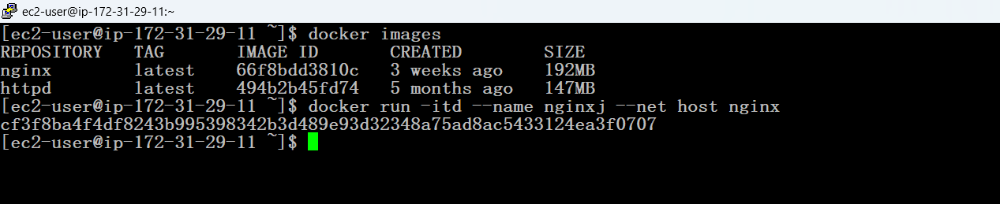



**None N/W Mode:**

* The **none network mode** in Docker is used when you want to disable networking for a container. When a container is run in this mode, it doesn’t have access to the network, meaning **it can't communicate with other containers or the outside world (including the host).**

